|  |  |
| --- | --- |
| **Ex. No. 4** | **Design a Website Landing Page with Navigation Bar and Login Form using CSS** |
| **Date of Exercise** | 06/08/2025 |
| **Git-hub Host Link** | <https://jksonjse.github.io/23CS2049-WEB-TECH/landing_page.html> |

**Aim**

To design and develop an HTML5-compliant single-page website with a fixed horizontal navigation bar, integrated logo, and title, featuring a visually engaging landing page background and a creatively styled login form. The page will be enhanced using CSS positioning, form styling, box shadows, rounded corners, and pseudo-classes such as hover , ensuring an intuitive, accessible, and aesthetically pleasing user experience.

**Description**

This HTML project presents a Landing Page with Navigation Bar and Login Form — a visually appealing single-page website built using HTML5 and CSS to provide an intuitive entry point for users. The page features a fixed horizontal navigation bar with a logo, title, and interactive menu links, ensuring easy access to different sections. A full-width background image enhances the landing page’s visual appeal, while a creatively styled login form is positioned using CSS for prominence and ease of use. CSS properties such as positioning, box shadows, rounded corners, and pseudo-classes like hover and focus are applied to improve interactivity and design aesthetics. Conforming to HTML5 standards, the page delivers a clean, accessible, and user-friendly interface optimized for a smooth first impression.

**Procedure:**

1. **Start the HTML Document**  
   Begin with the <!DOCTYPE html> declaration, then open the <html> tag and include the lang attribute to define the page’s language.
2. **Create the Head Section**  
   Inside the <head> tag, add:
   1. <meta charset="UTF-8"> for character encoding.
   2. <meta name="viewport" content="width=device-width, initial-scale=1.0"> for responsive scaling.
   3. A <title> for the page title.
   4. A <link> tag to connect an external CSS stylesheet for styling.
3. **Design the Body Layout**  
   Use the <body> tag to structure all visible content.  
   Divide the page into logical sections using <div> elements — for example, header, main, and footer.
4. **Build the Header Section**  
   Add a website title aligned to the left and a search box or login link aligned to the right.  
   Style the header using CSS properties such as font-size, display: flex, justify-content, align-items, or float.
5. **Insert a Banner Image**  
   Place a banner image below the header using an <img> tag or a CSS background-image.  
   Ensure the banner spans the full width of the viewport and is responsive.
6. **Add a Welcome Section**  
   Include a heading and a short paragraph introducing the website and its purpose.  
   Use CSS text formatting, padding, and margin for alignment and spacing.
7. **Create an Image Gallery**  
   Build a responsive gallery with equal-width boxes containing background images and captions.  
   Use CSS flex or grid layout, and apply properties like box-shadow, position, opacity, and text-align for style.
8. **Add Content Sections**  
   Create one or more content blocks that combine images and descriptive text side by side.  
   Alternate the placement of text and images for variety, using flex, grid, or float.
9. **Create the Footer Section**  
   Add a footer with copyright information.  
   Style it with background-color, color, padding, and optionally border-radius for a polished look.
10. **Finalize and Validate**  
    Add <!-- comments --> in the HTML for documentation.  
    Ensure all tags are properly closed.  
    Validate the HTML and CSS using **W3C Validator tools** to check for standard compliance and responsiveness.

**Program**

<!DOCTYPE html>

<html lang="en">

<head>

<meta charset="UTF-8">

<meta name="viewport" content="width=device-width, initial-scale=1.0">

<link rel="stylesheet" href="styles_4.css">

<title>University Management</title>

</head>

<body>

<hr id="hr">

<div id="header">

<div class="central-nav">

<div class="logo">

<a href="landing_page.html"><img src="logo-png.webp" alt="college logo" width="150px" height="150px"></a>

<h1>University Management</h1>

</div>

<div class="navbar">

<ul>

<li><a href="#home" class="active">Home</a></li>

<li><a href="#Management">Management</a></li>

<li><a href="#hostels">Hostels</a></li>

<li><a href="#Placements">Placements</a></li>

</ul>

</div>

</div>

</div>

<hr id="hr">

<div class="login">

<h1>Login</h1>

<form action="form-submission.html" method="post">

<div class="form-element-1">

<label for="gmail">Enter your Gmail: </label>

<input type="text" id="gmail" placeholder="sampleemail@gmail.com" required>

</div>

<div class="form-element-2">

<label for="pwd">Enter your Password: </label>

<input type="password" id="pwd" placeholder="P*ssw*rd" required>

</div>

<button id="button" type="submit" >Login</button>

</form>

</div>

</body>

</html>

**CSS:**

body{

transform: scale(0.9999); /* Scale down to 67% size */

transform-origin: top center; /* Keep scaling centered from top */

background-image: url(bg-image.jpg);

background-repeat: no-repeat;

background-size: cover;

/* background-position: center; */

}

#header{

/* display: flex; */

justify-content: space-between;

align-items: center;

}

.central-nav{

display: flex;

justify-content: space-between;

align-items: center;

background-color: black;

margin: 0;

}

.logo{

color: white;

display: flex;

align-items: center;

}

.logo img{

padding-right: 20px;

}

.logo h1{

color: white;

font-family: 'Franklin Gothic Medium', 'Arial Narrow', Arial, sans-serif;

}

.navbar{

display: flex;

}

.navbar ul{

display: flex;

list-style-type: none;

margin: 0;

padding: 0;

}

.navbar li{

padding-right: 10px;

font-size: larger;

font-weight: 400;

text-align: center;

}

.navbar a:hover{

color: black;

background-color: rgb(42, 178, 42);

opacity: 0.6;

}

.navbar a{

text-decoration: none;

color: white;

display: block;

padding: 50px 20px;

font-weight: 800;

/* background-color: ; */

/* opacity: 0.5;

background-color: black; */

/* background-color: black; */

}

/* .navbar a.active{

background-color: black;

} */

.login{

position: absolute;

top: 30%;

left: 27%;

/* transform: translate(-50%, -50%); */

background-color: rgb(0, 0, 0, 0.9);

border-radius: 10px;

box-shadow: 0 8px 20px rgba(0, 0, 0, 0.3);

width: 500px;

height: 100px;

margin-top: 170px;

padding: 50px;

padding-bottom: 120px;

text-align: left;

display: flex;

flex-direction: column;

gap: 15px;

align-items: center;

transition: 0.2s ease;

transform-origin: center center !important;

}

.login:hover{

transform:scale(1.2);

}

.login form{

padding-bottom: 10px

}

.login label{

color: white;

margin-bottom: 200px;

font-weight: 500;

}

.login h1{

color: white;

text-align: center;

padding-top: 0;

margin-top: 0px;

margin-bottom: 20px;

}

.form-element-1 label{

padding-bottom: 10px;

padding-right: 30px;

}

.form-element-2 label{

padding-bottom: 10px;

padding-right: 10px;

}

.form-element-1{

padding-bottom: 10px

}

.form-element-2{

padding-bottom: 10px

}

#button{

margin-left: 0 auto;

color: white;

background-color: rgb(39, 177, 39);

padding: 15px 30px;

border-radius: 10px;

margin-top: 20px;

margin-left: 110px;

}

#button:hover{

color: rgb(39, 177, 39);

background-color: white;

transform: scale(1.2);

transition-duration: 2s ease;;

}

**Output**

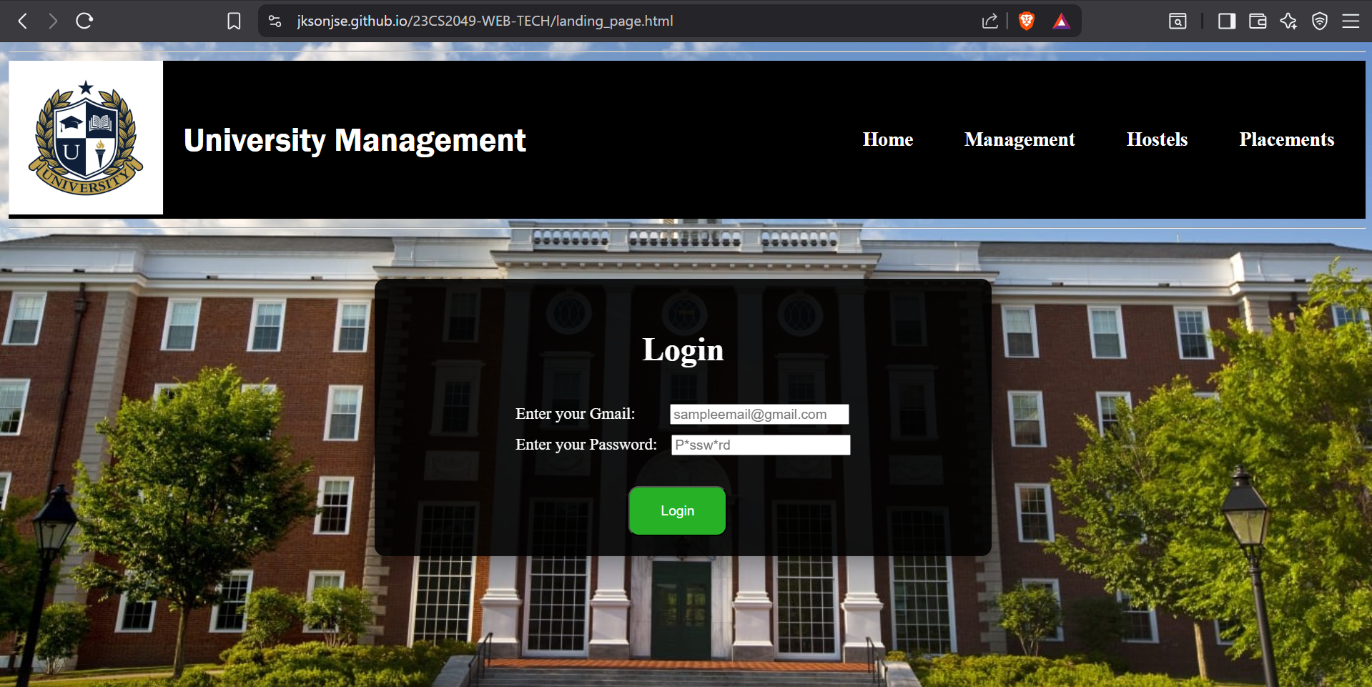

**Result**

The Landing Page with Navigation Bar and Login Form was developed using HTML5 and styled with CSS. It features a fixed navigation bar with a logo and title, a full-width background image, and a stylishly positioned login form. CSS techniques such as positioning, box shadows, rounded corners, flex/grid layouts, and hover/focus effects enhance both design and interactivity. The page is visually appealing, responsive, and meets all specified requirements.